ACKNOWLEDGEMENT

I take this extreme opportunity to express my sincere gratitude to all, for their invaluable contributions in this Mini-Project work. First of all, I am extremely thankful to the Management of DePaul Institute of Science & Technology, to Fr. Alex Chalangady, Principal of DePaul Institute of Science & Technology, Angamaly; for having given me the facilities to do this project under their support & inspiration.

I am grateful to Mr. Sajan Menon, my internal guide and to Mr. Thomas p.p, the Project and Lab coordinator, for their invaluable help and advices in the lab and classroom. I am also thankful to all the staffs in the lab and to all teaching and non-teaching staff for their sincere assistance during my project period. I endow my sincere thanks to DSOFT SOLUTIONS a part of DePaul Institute Of Science & Technology for granting me to do their Project in their esteemed Institution.

I am also thankful to my family members and friends, for their full co-operation and mental support. Above all, I bend my knees in front of God the almighty, for putting all the skills and abilities to do my work efficiently. Once again I like to thank everyone who helped me to complete my work in all aspects. Thank you. ABRAHAM VARGHESE

INTRODUCTION

The development of science and Technology is so rapid that the existence of the entire mankind is dependent on the implementation of scientific knowledge. Entire world is paying much attention to improve its life style by synthesizing the result of gaining the classical as well as modern knowledge. It is under these circumstances that computerization becomes relevant.

The competitiveness of the industrial scenario compels all the organizations to evolve ways and means to keep its operational efficiency at its peak to service. To achieve this, the integration of the operational domain of the organization is essential given the complexity of functions changing the market condition, migration of functional personnel and competition from parallel players make this task even more difficult.

Speeding of the business by cutting short cycle time by maintaining costs and improving quality is the greatest challenge of the industry. Manufacturing is at cross roads today. To respond to the pressure, the organization should have control, flexibility and integration of systems, functions and communication with in the system.

SYNOPSIS

TITLE OF THE PROJECT:

The title of the project is PROJECT SHEDULER .This system meant for creating a Project Schedule for different Projects and analyzing the progress of Projects and its subtasks afterwards. Also the PROJECT SHEDULER creates and maintains a personnel database to keep the details of project and task managers.

ORGANIZATION WHERE THE PROJECT IS UNDERTAKEN:

The project is undertaken for DSOFT a part of De Paul institute of Science and technology. The Project is done for DSOFT SOLUTIONS a part of DePaul Institute Of Science & Technology, Angamaly. The earlier system in the institution for PRIJECT SHEDULING is manual and tedious. If this SHEDULIG process is automated then a lot of human hours and efforts can be saved. Also maintaining a data base provides quick and correct data for analysis that is not possible in the human system.

TOOLS USED:

This is a database project and hence we are using Visual Basic as front end and Oracle as back end. The connection between these two is established by ADO (ActiveX data objects) connection which is more powerful than DAO, RDO connections.

MODULES COVERED AS A PART OF THE PROJECT:

Project Scheduling:
This module is meant for creating a new project schedule for a project. We add tasks and set their relationship in this module. The scheduler now calculates and establishes task relationships according to the user requirements and automatically calculates the assumed starting date of each task and stores it in the database for later processing

Project Analyzing:
This module is meant for understanding the progress of a project by analyzing the subtasks involved. This is established by analyzing the starting and ending date of the subtasks and the delay of the tasks from their assumed starting date. Also there arises a comparison between the actual and assumed duration of a task. All these information are used to generate reports that give a clear idea about the project and tasks and their progress. Also the state of the project in the future can be predicted.

Project Updating:
A project’s progress, i.e. starting and completion of tasks can be recorded, so that we can analyze the project’s progress in Project Analysis .There are mainly 3 kinds updations.

- Project/Task starting or ending date updation.
- Project/Task reedits updation.
- Adding a new task to the current project schedule.
- Changing Managers of Projects/Tasks.

Personnel management:
The Project Scheduler also keeps and maintains a personnel database for keeping personnel, so that the projects or tasks can be scheduled to persons reside in the institution. Also this makes it possible to generate personnel reports that integrate the project environment information with human environment information, so that we can analyze a person’s efficiency in his work. For this purpose the Scheduler keeps a Register to record the working information of persons in projects/subtasks.

HARDWARE AND SOFTWARE REQUIREMENTS

HARDWARE PLATFORM

Processor - INTEL Celeron or INTEL Pentium series, AMD
Processors.
Ram - 32 MB or more.

Hard Disk Space - 500 MB (SAMSUNG 40 GB HDD).

Printer - Dot matrix (WIPRO LX-18], Inkjet (HP-640C).

Adapter Card - Any GUI supporting graphics card
(Any super visual graphics adapter (SVGA))
Like RIVA TNT.
Monitor - SAMTRON 14”/15”/17”.

SOFTWARE PLATFORM

Operating System - Any multithreading or multitasking OS under
Microsoft.
(E.g. Windows 95/98/2000 or Windows XP)

Software Tool -
Front End: Microsoft Visual Basic 6.
Back End: Oracle 8I/9I or Microsoft Access.

FEATURES OF VISUAL BASIC 6.0

Microsoft Visual Basic 6.0 is member of Microsoft Visual Studio 6.0, which provides a very easiest way to develop windows applications. Whether you are doing a database project or other window level programming, VB 6.0 provides the complete set of tools to develop your applications efficiently and easily.

Visual Basic 6.0 is a object based, not purely a object oriented language. It is fully equipped with ready-made objects .Even though it is object based it provides a lot of advantages that a object oriented system will support. Here we will create data structures which simply represent objects in the system. This language is easy to use so that one who is not familiar with window programming can develop window applications easily.

The language support Multiple Document Interface(MDI), Object Linking & Embedding (OLE), Dynamic Data Exchange (DDE) between OLE objects & the objects in the program, ActiveX controls, ActiveX documents, OLE automation(CODE COMPONENTS) and ActiveX DLLs. Visual Basic applications can be extended by using these existing ActiveX controls and ActiveX DLLs from which we can call procedures at run time. Multiple applications can share DLLs which saves memory and disk space apart from the fact that it reduces the size of the source code. This will increase the program modularity.

VB 6.0 has a large number of built-in objects which the user can use with maximum flexibility. The only task to do is to incorporate these controls to the programs. The core of VB programming is a set of independent set of code that are activated by events that they have been told to recognize.

We can use ActiveX EXE components which will viewed as a OUT-PROCESS, that means it will run independently from the program that contains it. But ActiveX DLLs is an IN-PROCESS that means which will be included and run in the actual program’s environment, that will cause an increase in the speed of the execution since the control does not have to cross the program’s boundaries as in the case of ActiveX EXEs.

Within the project we created a user-defined ActiveX-Control to implement a Date-Calculator. Beside these components V.B.6.0 provides a lot of methods and procedures that are required more often during the development of projects. The date-calculation methods are a perfect example to show this fact.

V.B.6.0 is more powerful than its earlier versions such as V.B.5.0 and V.B.4.0. For e.g. VB.6.0 contains Active-X-Data-Objects for accessing remote databases. And this facility is not supported by the earlier versions. Using this special object we can access a specified database, which resides in any client in a network. The program that accesses the database can be any where in the network. That means the program may be in any of the client connected to the network.

ORACLE CORPORATION HISTORY

The Oracle Corporation began producing database software in 1977. Since then the company has created a variety of tools and products for the ORACLE RDBMS. Developers new to ORACLE usually want to know what the current set of tools like, why specific tools have replaced others, how all these tools work together, and what can be expected from oracle corporation in future.

IBM originally developed ORACLE for its system R project. The relational model was first detailed in a 1970 paper written by E.F.Codd, who was working for IBM and had implemented his ideas in the ALPHA model. In 1977, IBM sold ORACLE to Relational Software Inc.(RSI), a company started by Lawrence J.Ellison and Ribert Miner. In 1979, RSI introduced ORACLE V2.O, the first commercially available RDBMS and the first commercially available SQL-based DBMS. In 1983, RSI changed its company name to Oracle Corporation and began distributing the first portable DBMS.

In 1986, Oracle corporation released the first distributed DBMS, the same year that ANSI established SQL as the standard for RDBMS, Oracle Corporation’s most recent accomplishment is distribution of the first high performance DBMS (8I/9I versions).

WHY CHOOSE ORACLE SERVER? :

Oracle is a Relational Database Management system. This collection of tools, utilities, and applications lets you manipulate an ORACLE database. Many of these products are fourth-generation language tools; they let you use interactive screens to create application programs.

The ORACLE was designed using the relational model and gives users many advantages, including the following:

- A database structure that is easy to visualize and understand.
- The ability to create any number of temporary relationships between tables.
- Freedom from concerns about how to query the database, through the use of SQL (structured query language, pronounced ‘SEQUEL’)
- Tables easy to visualize.
- Relational joins that provide temporary sets of data from multiple tables in the model.

In relational database, query capabilities can be supplied by any of several query languages. The ORACLE system uses the nonprocedural structured query language (SQL) to communicate with its database kernel. In 1986 the American National Standards Institute (ANSI) made SQL the standard for all RDBMS.

Because ORACLE uses SQL as its query language and makes available numerous tools to support the system, ORACLE provides the following advantages over other relational databases:

- Direct SQL interface to the database helps to interact with the database and manipulate it directly.
- The transferability of data files from many file and flat-file formats into the table structures of an ORACLE database, using the utility SQL * loader, reduces problems in data conversion to ORACLE database.

OTHER FEATURES:

The other features include:

- PORTABLE - ORACLE software is posted to work under different operating systems, therefore it is primarily the same on all systems.
- COMPATIBLE – ORACLE software is compatible on most industry standard operating systems. Therefore applications developed for ORACLE can be used on any system with no modification.
- CONNECTABLE – ORACLE software allows different types of computers and operating systems to share information on real time-basis.

These capabilities result in a comprehensive and powerful system for information storage and retrieval across virtually all hardware and software platforms.

SYSTEM STUDY

System Study is generic term that refers to a systematic study and process for identifying and solving realistic problems.

PROBLEM DEFENITION

The aim of undertaking the project called the Project Scheduler is to manage any type of projects efficiently and easily. Now a days processes constitutes of a sequence of ordered step or a procedure which can be viewed as a step by step process including building construction; production of products like foods, garments etc; development of software products are managed as a project schedule.

This requires analyzing and managing the progress of each task in a main process in a systematic way. Also it must be necessary that each task must be analyzed in such a way that the overall status of the corresponding task can be interpreted in a better way by using Activity on Node diagram, Chart etc. Our aim is to implement a system which has the main function, to schedule projects for an enterprise, so that the system will provide basic functions of a Mini Project Scheduler.

ARCHITECTURE OF THE EXISTING SYSTEM

The PROJECT-SCHEDULING technique is fully performed manually, which is a nightmare when the projects to be scheduled or analyzed consist of a large number of subtasks or if the number of projects to be handled is very large in number. All the project scheduling in formations are done by manual efforts that is more likely to be error prone. Also there is immense calculations are done

on dates so that the calculation of days in months, adding a date with a number, subtracting two dates to get the difference in days, months and years are performed manually in the existing system which is harder to perform. Also most of the time is spend on these calculations since it requires a lot of mathematical calculations, so that a lot of man hour is wasted in the unimportant part of the system. Also there is not a systematic approach in the existing system such as PERT (Project Evaluation & Review Technique), CPM (Critical Path method).That means that the scheduling information itself may proved to be incorrect. To implement these techniques one must know thoroughly about these concepts which is harder to achieve since this area is very wide.

Whenever there is a need to schedule a project the PROJECT-SHEDULER (man in the existing system), have to find the persons available so that the tasks can be allotted to them. Also he has to check whether the selected person is working on other projects etc. After it he has to record the project and the tasks information’s in a paper or in a computerized spread sheet like MS-EXCEL or MS-WORD.

Then he has to calculate all assumed starting dates of the subtasks according with the project ‘s start date which is the most tedious work since it involves the processing of predecessor tasks of the tasks whose start date is to be calculated.

The other problem is that rescheduling the project involves the wasting of resources such as paper and time. Imagine if we have to occasionally change the starting date of a project, or we have to change the duration of tasks under a project since the assumed standards are likely to be deviated from the real situations. Adding a new task to an existing schedule is also struck with the same problem. But these changes are always happens with a project schedule. That means all the scheduling process have to be repeated over and over again under these changes that makes the scheduling inconsistent and inefficient.

The REPORT generations on the Project Schedules are done by manual effort in the existing system. Since reports generations are done by man it is more likely to be erroneous .The reports are directly generated by evaluating the tasks and their pre assumed standards. Also there provided not more than two reports, one on entire project and one on individual tasks. Also the reports tell us that how much a task is delayed and it’s affect on the project. There is no mentioning about the cumulative delay on the project by a group of tasks. Also checking starting dates for subtasks for validity or checking the validity of a task’s duration requires complete scanning of the entire project schedule thoroughly and a man may not cope with such a situation. There are no REPORTS on the affects that a task have on another. There is no provision for knowing about the working condition of a person in his subtask, such that there is no way to recognize the fact that whether the person appeared for his work between two dates or in an interval. So personnel accessing is not very efficient. There is no report on such an area.

There is no provision to analyze a project schedule by graphical methods which makes the progress of a schedule more clearer .This is because as previously mentioned the existing system is does not built on the project scheduling techniques. Also creating graphics manually needs a lot of time and efforts.

Also the maintaining of the personnel database is separate from the Project Scheduler, So that we cannot co-operate these two areas efficiently. Such a facility must be provided since Project Scheduling consists of manpower scheduling also.

DRAWBACKS OF THE EXISTING SYSTEM

- Requires a lot of manual processing.
- Highly prone to human errors.
- Needs a lot of human efforts and time.
- Not based on a systematic approach.
- Report generation is very difficult.
- No graphical methods supported.
- Scheduling/Rescheduling/Analyzing of a project is not efficient.
- A transaction such as updating a project is very tedious.
- No direct dependence between personnel information and scheduling information.
- No personnel accessing/No personnel reports related to a Project Schedule.

ARCHITECTURE OF THE PROPOSED SYSTEM

The proposed system called the PROJECT SCHEDULER does the automation of project scheduling unit of DSOFT SOLUTIONS a part of DePaul Institute Of Science & Technology, Angamaly. The system provides a means by which the system user can perform Project Scheduling, Project Analyzing, Project Rescheduling, Project Transactions and Personnel database maintenance.

The proposed system completely rely on PERT (project evaluation & review technique) and CPM (critical path method) which is a systematic approach to PROJECT-SHEDULING. Using these concepts the PSHEDULER will take the advantages of the concepts EARLY START, LATE START, EARLY FINISH, LATE FINISH time of a task, FREE SLACK and TOTAL SLACK of a task, CRITICAL PATH (an ordered sequence of subtasks) of a project etc. Also this approach introduces a GRAPHICAL ANALYSER of a project which in turn generates three graphical models of a project collectively called GANTT-CHARTS, introduced by a scientist named GANTT. The charts under consideration are EARLY-START-GANTT-CHART, LATE-START-GANTT-CHART, REAL-START-GANTT-CHART.

The proposed system guarantees that the ultimate control of project scheduling is rest on the hands of the administrator group. The Project Scheduler will provide an option to make the administrators group. This category of users will schedule projects or reschedule projects for the enterprise. The first step of scheduling is to read details of the project and allot it to a project manager who is selected from the personnel database. And the project manager is provided with a password so that he can access his project later for viewing the progress or to update the project’s status. After registering the project the next step is to schedule the subtasks under the project to different task managers. These task managers are completely under the control of the project manager. The project manager can analyze the progress of task managers under his project from the PERSONNEL REGISTRY in which the task managers make their day to day progress on their task.

The next step is the core part of the design of the software called PROJECT-SHEDULER .It is the real Project Scheduling done by the machine which a man cannot do easily or accurately. It involves setting relationships among the various subtasks under a project with the help of the user. By these relationships and starting date of the project the software called PSHEDULER automatically calculates the time interval for each task with in which the task must be supposed to be start. If the task starts with in the specified interval it will not cause a delay in the entire project, but which will not the case always. The real progress of the task will be very much deviated from the assumed standards since they are carried out by humans and humans are subject to various limitations.

After scheduling a project the next step is to view its progress or to record its progress. This can be done by the respective project manager with his password or by an administrator.

Administrators have the right to access all the projects and all the tasks that are undertaken with in the enterprise. Updating means is to record the real starting and ending date of the subtasks under the project. Viewing means providing various reports on the projects and tasks. The project report tells us about the progress of the project up to the current state with the cumulative delay in the project. The task report tells us about the starting and ending status of the tasks and there is a comparison is taken between these facts and the pre assumed standards. Also affect of a task on another can be analyzed easily. Also graphical analysis of a project is done by generating different kinds of GANTT-CHARTS mentioned earlier. This part of the PSHEDULER is collectively called PROJECT ANALYSIS/PROJECT UPDATING. Rescheduling the project means changing the start date of the project which is not already started, changing the duration of a task that is not already completed or started, changing the project or task managers of in completed project or task, add a new task to a project with its relation with other existing tasks etc. Some of these processes require the recalculation of the starting and ending date of each task, hence we given the name RESHEDULING. The RESHEDULER which is a part of the PROJECT-SHEDULER will deals with these changes efficiently and with a greater speed that a human can never imagine. Also the rescheduled information is stored safely for later retrieval of rescheduling. Also reediting the project information or task information also comes under the category called rescheduling.

The very specialty of the PROJECT-SHEDULER is that, it does not see the human entity as a different part from the project scheduling. Since humans are the final entity who controls the projects and subtasks under the name like project managers or task mangers, the PROJECT-SHEDULER maintains a PERSONNEL-DATABASE to create a pool of human resources so that adequate persons are selected to handle a project or a task whenever the administrator schedules a project. Maintain a personnel database means it must provide a means of adding new personnel to the existing pool, or it must be possible to remove a person from the pool. It must also provide a facility to change the information about personnel. In this kind of PERSONNEL POOL each personnel is provided with a unique PERSON_ID by which he is distinguished from other persons.

ANTICIPATED BENEFITS OF THE PROPOSED SYSTEM

- All the drawbacks of the existing system are guaranteed to be eliminated.
- Requires a very little manual processing.
- Errors will be reduced due to little intervention of humans.
- Adequate data validations will be provided.
- Based on a systematic approach (PERT &CPM) will ensure greater reliability and accuracy.
- Report generation is handled by the machine makes it more accurate.
- Graphical Analyzing Methods are supported by the system.
E.g. GANTT-CHARTS, AON (Activity on Node Diagrams) prepared on projects.
- Scheduling/Rescheduling/Analyzing of a project is very efficient and there is, a less possibility for errors.
- A transaction such as updating a project is easier to manage.
- Direct dependence between personnel information and scheduling information.
- Direct personnel management. Provides PERSONNEL-REPORTS related to a Project Schedule.
- Guarantees CENTRALIZED_CONTROL by the administrator group.
- Query statements used will speed up data retrieval and storing.
- All reports are prepared at the abstract level, so that quick actions can be taken to; prevent undesirable problems that are likely to be happening during the progress of a project, with no time.

FEASIBILITY STUDY

Feasibility study is system proposal according to its works, ability, impact on the operation, ability to meet user needs and efficient use of resources. During product engineering we concentrated our attention on three primary areas.

- ECONOMIC FEASIBILITY.
- TECHNICAL FEASIBILITY.
- BEHAVIRAL FEASIBILITY.

ECONOMICAL FEASIBILITY

The most important information contained in this feasibility study is COST-BENEFIT-ANALYSIS, an assessment of the economic justification for a computer based system project like ‘PROJECT SCHEDULER’. Cost benefit analysis delineates costs for project development and weighs them against tangible and intangible benefits of a system. If these benefits outweigh cost, decision to implement this system is made; otherwise other alternatives have to be found out. This project is cost effective because of increased customer satisfaction, through programmable control, better business decisions through reformatted data, better design, quality, accuracy, greater speed & user friendliness, are all obtained by reduced time, effort and cost.

TECHNICAL FEASIBILITY

Technical feasibility emphasizes on the existing computer system (HW & SW) and to what extend it will support the proposed system. The considerations which were normally associated with the technical feasibility included.

* Development Risk: that is whether the system could be designed with necessary functions and performance within the constraints we uncovered during analysis.

* Resource Availability: that is whether the necessary hardware and software resources are available and whether we were skilled enough to develop the system.

BEHAVIORAL FEASIBILITY

People are inherently resistant to change and computers have been known to facilitate the change. Since the system is user friendly, user training can be done easily and efficiently. VISUAL BASIC 6.0 is a GUI, so anyone can easily use it without any prior knowledge of it.

All the system facilities are controlled or accessed by MENUS and BUTTONS, which reduces the complexity in handling the implemented system. Also the inputs from the keyboard are limited as far as possible and selection through mouse is more emphasized for reducing the rate of human errors during inputting.

SYSTEM DESIGN

System Design is a process by which we develop the PROPOSED-SYSTEM through a sequence of interdependent sub processes. Therefore System Design is categorized in to four sub designing processes namely:

- DESIGN OF MODULES.
- DESIGN OF INPUT.
- DESIGN OF OUTPUT.
- DESIGN OF DATABASE.

MODULARIZATION

Modularization is the process by which the entire program or software is divided into independent or partially dependant units called modules which can be developed, tested, debugged separately. That means we can develop these units easily and separately without a through understanding of other modules. Modularization can be achieved in two ways, TOP-DOWN modularization or BOTTOM-UP modularization. Here the entire software is modularized in TOP-DOWN fashion. Our software called PROJECT-SCHEDULER is mainly divided into two modules.

- PERSONNEL MANAGEMENT
- PROJECT MANAGEMENT.

PERSONNEL MANAGEMENT

Personnel Management is a section which manages personals. These section or module include sub modules which meant for adding a new person to the enterprise, editing an existing person, removing an existing person from the enterprise, selecting an existing person for performing managerial functions for a project or subtask under a project.

The Project Management produces PERSONNEL REPORTS with the help or Personnel Management.

The other main sub module that the Personnel Management contains is the PERSONNEL REGISTRY MANAGEMENT module. This section is responsible for allowing task managers to enter their attendance in the register. Also they can enter their remarks and other kind of information in the registry. So as we can see the PERSONNEL REGISTRY contains two subsections, one which allows new entries in the register and the other helps to analyze or view the personnel registry with different kind of privileges for different kind of users such as administrators, project managers, task managers etc.

PROJECT MANAGEMENT

This module is the one which manages all the activities related to Project Scheduling. This module is again divided into 4 sub modules namely.

- New Project Scheduler.
- Existing Project Re Scheduler.
- Report Generator.
- Existing Project Updating.

New Project Scheduler:
This sub module manages the entering or registering of new projects with in the enterprise. The major subsection of this module is the TASK-SCHEDULER which is meant for registering the tasks under the project. This subsection is responsible for registering new tasks under the project, deleting tasks under the project etc. Also the TASK-SCHEDULER does the core part of PROJECT_SCHEDULING which involves calculation of Early Start Date (ESD) and Late Start Date (LSD) of a subtask. It is also this module which allows the user to set relationships among the subtasks. This helps in defining predecessor tasks and successor tasks of a subtask under a project. This module has an interconnection with the personnel management for accessing persons for getting project and task managers.

Existing Project Re Scheduler:
This module handles all the critical changes to an existing project schedule generated by the New Project Scheduler. The sub sections that comes under this module is given below.

Adding subtask to an existing project: This involves adding one or more new tasks to an existing project, which also requires the calculation of ESD and LSD for the tasks again. So this task is partially dependant on the module called TASK-SCHEDULER which is a sub module of New Project Scheduler.

Changing start date of project/Changing duration of a subtask: These are the changes which are usually happens to a project schedule. These changes also requires the recalculation of ESD and LSD, so like the module mentioned previously this module also partially dependent on the module called TASK-SCHEDULER which is a sub module of New Project Scheduler.

Changing project/task mangers: These changes involve removing old manager from a project or a task so that the schedule can be hand over to an efficient person in all aspects so that the throughput is maximized. As from the module’s name we can understand that this module is dependent on the personnel Management module for handling persons.

Report Generator:
This module handles the outputs of the software to the user. This module is subdivided as follows.

General Report: This report gives the names and status of all projects undertaken by the enterprise. The status tells whether the project is active or not, since it can be a deleted project. Also it tells about its completion status. This is the simplest report compared to other reports.

Personnel Report: This report is actually a project report, but here the importance is given to persons. This report give an out look on a person’s working in his subtask. This report tells about the persons who worked or working in a project or a subtask. Also this report gives the details of persons who worked in their task during a specified interval of time or between two dates, so this section also depends upon the Personnel Management Module.

Task reports: These are reports about subtasks under a project. This area of report is wide as compared to other reports. This module includes reports about a particular task which tells about its pre assumed standards, its current status of progress; it’s starting and ending status, its effect on the entire project. Another kind of task report is also provided which mainly concerned with task relationships. That means the effect of one task on its successor tasks or the effect of predecessor tasks on a particular task etc. This tells about how a particular task affected the other like the reduction of slack time, the delay caused for starting of the task etc. So this module incorporates more than one kind of report.

Project report: This report gives an idea about a projects current progress and delay if any. This report also incorporates the entire tasks under the specified project with their staring and ending status. Also information is based on the comparison between the pre assumed standards and the actual progress of the tasks.

Critical Path Report: This report gives the idea about the critical paths in a project and their assumed duration.

GANTT-CHART-GENERATOR: This is actually not a report, but a visual effect provided to the user to understand the progress of his project easier. Since it is an output to the user we mention about this here. There provided mainly 3 types of GANTT-CHART namely EARLY-START GANTT-CHART, LATE-START GANTT-CHART, REAL-START GANTT-CHART.

Also along with the Gantt chart there provided graphical representation of the project structure using graph. This method is named as ACTIVITY ON NODE DIAGROM. There are two such representation , one is for representing all the PATHS between the final and initial tasks within the project structure and the next one is for representing all CRITICAL PATHS with in the project. But actually this category is separate module from the Gantt chart generator module.

This module is generally called AON-GENERATOR, which generates AON-Graphs of two types. This module is little more complex and hence detail description about this module is included in the CONCLUSION section of this DOCUMENT.

Existing Project Updating:
There are mainly two sub modules under this module.

Starting or Ending Date fixing Of a Subtask: This module gives us the option to record the real staring or ending time of subtask under a project. A lot of checking needed is incorporated in this module. These dates are the actual starting or ending date of a task which is used to compare with the ESD and LSD to generate task and project reports.

Project/Task Description Re-editor: This modules helps in changing the descriptions of a project or a subtask under a project under certain circumstances, such as the change in the duration of a task also changes the coast in order to undertaken it.

INPUT DESIGN

The input design comprises of the design of forms through which various types of inputs can be given to the implemented system. The INPUT FORMS comes mainly under the categories namely, Entry screens, Edit screens, Delete screens etc.

Entry Screens: These include screens with options to enter to the system with appropriate privilege, enter a new project, enter tasks under the project, enter relationships among tasks under a project, enter new person, add a new register entry and add a new administrator.

- Entering to the system – This form provides options to enter to the system with different privileges. That is the user is divided in to Task manger or simply person, Project manager, Administrator. So they have to supply their username and password to login properly. This screen provides facilities to enter this information along with options to select projects and their ID’s to explore the projects and personnel registry.
- New Project – This form provides options to add a new project to the database. Here we enter project’s name, description, starting date, Project manager’s ID etc.
- Tasks under a Project – This form is used to enter tasks under a project which constitutes of Task’s name, duration, description, manager ID etc.
- Entering relationships among the tasks under a project – This form provides option to set relationship among tasks under a project. The user has the option to select tasks from a list and set its neighbors from other list.
- New Person entry – Through this form we add a new person to the enterprise. The details here we enter includes Person’s name, date of birth, skills, remarks, address, sex, qualification etc.
- New Register entry – This form is used to enter entries in the personnel register. That is this form is act as a actual register for task managers to record their day to day activities such as their entering time, leaving time, difficulties, errors etc.
- New Administrator entry – This form add a new administrator to the enterprise. The name and password to login must be supplied by him.

Edit Screens: These includes forms to update a task’s state, project’s description, task’s description, project’s manger, task’s manager, project’s start date, task’s duration, adding tasks to a project.

- Status updation of a Task – This form is used to enter the starting and ending date of a subtask under a particular project. The user is provided with a facility to select appropriate tasks to set these changes
- Updation of Project’s/Task’s description – Using these form we can change the existing description of a project or task. For easy handling these two facilities are integrated to a single unit.
- Changing Project’s/Task’s manager – This form provides an option to select a new manager for a project or for a task under a project. The project/task assigned date for the new manger must also be supplied.
- Changing project’s start date/Task’s duration: This form is used to change the starting date of a project or to change the duration of a task under a project. For the first option the user have to supply the project-id and the new starting date. The second option needs the selection of task under a project along with the changed duration.
- Adding tasks to an existing project: This is similar to the task entry in the ENTRY SCREEN SECTION. Also user has to set the relationship of the entered task with other task as discussed above in the ENTRY SCREEN SECTION.

Delete Screens: This screen includes option for delete a project, delete tasks of a project etc.

- Deletion of Project: The deletion of project means remove the project from the enterprise temporarily. For that the user has to select the project from a list of projects, to be deleted. The recalling of a deleted project is accommodated in the same screen with a similar procedure. Recalling a deleted project will make it an active project once again.
- Deletion of tasks from a project: Option for deleting tasks is provided in the task entry screen for better handling of tasks of specified project. The user will be provided with a list of tasks of the project that he entered through the Task entry screen. He has the option to select tasks from this list for deletion purpose.

OUTPUT DESIGN

The Output design comprises of the design of forms through which various types of outputs can be obtained from the system. The output forms come mainly under two categories – Master, Reports.

Master Screens: These screens are again subdivided to two namely GRAPHICAL ANALYZERS OF PROJECT and AON GRAPHICAL ANALYZERS.

- GRAPHICAL ANALYZERS OF PROJECT – This category of forms include forms that provide an option for visualizing the project using the system. They are again subdivided to two namely GANTT-CHART-GENERATOR and AON-GENERATOR. Gantt-Chart-Generator generates three types of Gantt Charts namely EARLY-START-GANTT-CHART, LATE-START-GANTT-CHART and REAL-START-GANTT-CHART. AON-GENERATES Activity-On-Node-Diagrams (AON-Diagrams) for ALL-PATHS in the project and for the CRITICAL-PATHS in the project.
- NON GRAPHICAL ANALYZERS – These includes forms that will display the contents of PERSONNEL-REGISTER for persons working as task managers under a project, the contents of PERSONNEL-DATABASE, SIMPLE-PROJECT/TASK-VIEW etc.

REPORTS: The reports are classified to three categories namely PERSONNEL-REPORT, PROJECT-REPORT, TASK-REPORT.

- PERSONNEL REPORT – This Report provides information about personals working under a project along with their progress in their task. It also provides information about the working hours of the persons.
- PROJECT REPORT – There are mainly two PROJECT-REPORTS: ALL-PROJECT-REPORT and SINGLE-PROJECT-REPORT. ALL-PROJECT-REPORT provides the information about all the projects under taken by the Enterprise along with their status and other information. SINGLE-PROJECT-REPORT gives an overall idea about a project along with its associated task’s information and the project’s progress. It gives an idea about the project’s current status with a powerful comparison with the assumed standards of the project.
- TASK REPORT – These REPORTS mainly classified to two: TASK-REPORT and RELATED-TASK-REPORT. The TASK-REPORT provides complete information about a task along with its starting and ending status and it’s affect on the entire project. Two reports are generated in the category RELATED-TASK-REPORT for each task. One is to show the affect of the task on its each successor task and the second is for showing the affect of each predecessor task on the specified task.

DATABASE DESIGN

Database design is the process by which we design a data store, which is used for storing details required by the software permanently. For that we have to design tables to keep interrelated information so that retrieval of data is efficient and loss less. The designing of database is come across a sequence of processes so that the design will provide the maximum throughput. Here comes the concept of NORMALIZATION.NORMALIZING a database means decomposing the tables so that data retrieval using queries are most efficient and there is no data loss. Our tables are came across three kinds of normalizations called,

- First Normal Form
- Second Normal Form
- Third Normal

Initially we analyze our software requirement so that we can determine the information fields, which we want, and we represent them in a single group or table. This row database is said to be in ZERO NORMAL FORM. That is each field may contain multiple values. This situation should be avoided since it throws away the concept of data integrity and retrieval efficiency.

So we will move on to the next step that is bring this raw design of database to FIRST NORMAL FORM which removes multiples values from each field so that a field will contains at most one value at a time. Designing a database in FIRST NORMAL FORM will provide certain advantages such as easy data retrieval. But this is not enough for getting the maximum advantage we will improve our design to the THIRD NORMAL FORM, which have the property that it must be in the SECOND NORMAL FORM and all the non-prime attributes are fully dependent on the primary key entirely. Then there arise the concept of SECOND NORMAL FORM, which tells that all the attributes must be fully dependent on the candidate keys only. Also the next step is to improve our database design to BCNF (Boycott NORMAL FORM), which states that all the transitive dependencies between the attributes must be eliminated. But we are not gone for this extreme step. So our database design is in the THIRD NORMAL FORM.

Finally we analyzed the table design and database design once again to check the fields for their proper type and the relations that we set among tables. And there by we concluded that all the relation that we set among tables are of proper type and having the required efficiency to record and retrieve information in fast and reliable manner.

TABLES USED

1. PROJECTS.
This table contains major details of scheduled projects, such as starting date, description etc.

SNO | FIELDNAME | DATA TYPE | SIZE | DESCRIPTION
1. | PROJID | NUMBER | 7 | PROJECT ID
2. | PROJNAME | VARCHAR2 | 30 | PROJECT NAME
3. | PROJDESC | VARCHAR2 | 200 | PROJECT DESCRIPTION
4. | PROJDURATION | NUMBER | 8 | PROJECT DURATION
5. | PROJSTARTDATE | DATE | - | PROJECT START DATE
6. | PROJMANAGER | NUMBER | 7 | PROJECT MANAGER ID
7. | COMPLETED | VARCHAR2 | 1 | COMPLETION STATUS
8. | DELETED | VARCHAR2 | 1 | STATES-PROJECT DELETED OR NOT
PRIMARY KEY IS PROJID.

2. PERSONS.
This table contains information about persons who are working under the enterprise, Such as address, name etc.

SNO | FIELDNAME | DATA TYPE | SIZE | DESCRIPTION
1. | NAME | VARCHAR2 | 50 | NAME OF THE PERSON
2. | ADDRESS | VARCHAR2 | 200 | PERSONNEL ADDRESS
3. | AGE | DATE |  | DATE OF BIRTH
4. | SEX | VARCHAR2 | 1 | SEX OF THE PERSON
5. | ID | NUMBER | 7 | PERSONNEL ID
6. | WORKINGFOR | VARCHAR2 | 200 | WORKING INSTITUTION
7. | FIELDINTERESTED | VARCHAR2 | 25 | INTERESTED FIELD
8. | QUALIFICATION | VARCHAR2 | 100 | PERSONNEL QUALIFICATION
9. | REMARKS | VARCHAR2 | 200 | OTHER INFORMATIONS
10. | EXSIST | VARCHAR2 | 1 | PRESENCE OR ABSENCE
PRIMARY KEY IS ID.

3. PASSWORDSTORE.
This table is used to store passwords of project managers. The project managers use this password to access his project later.

SNO | FIELDNAME | DATA TYPE | SIZE | DESCRIPTION
1. | PROJID | NUMBER | 7 | PROJECT ID
2. | PROJMANAGER | NUMBER | 7 | PROJECT MANAGER ID
3. | PROJPASSWORD | VARCHAR2 | 50 | PASSWORD
PRIMARY KEY (PROJID).
FOREIGN KEY(PROJID) REFERENCE TABLE PROJECTS.

4. SUBTASKS.
This table contains details about subtasks under a project schedule like task name and task manager ID.

SNO | FIELDNAME | DATA TYPE | SIZE | DESCRIPTION
1. | TASKID | NUMBER | 7 | SUBTASK ID
2. | PROJID | NUMBER | 7 | PROJECT ID
3. | TASKNAME | VARCHAR2 | 30 | NAME OF THE TASK
4. | TASKDESC | VARCHAR2 | 200 | TASK-DESCRIPTION
5. | TASKDURATION | NUMBER | 20 | DURATION OF THE TASK
6. | TASKEARLY | DATE | - | TASK’S-EARLY-START
7. | TASKLATE | DATE | - | TASK’S-LATE-START
8. | TASKMANAGER | NUMBER | 7 | TASK MANGER ID
PRIMARY KEY (PROJID, TASKID).
FOREIGN KEY (PROJID) REFERENCE TABLE PROJECTS.

5. PREDECESSORTASKS.
This table is meant for storing details of predecessor tasks of a subtask under a project. That is it is used to store task relations. Predecessor tasks of a subtask are the tasks, which are to be completed before the subtask would begin.

SNO | FIELDNAME | DATA TYPE | SIZE | DESCRIPTION
1. | TASKID | NUMBER | 7 | SUBTASK ID
2. | PROJID | NUMBER | 7 | PROJECT ID
3. | TASKRELATED | NUMBER | 7 | PREDECESSOR TASK ID
PRIMARY KEY (PROJID,TASKID).
FOREIGN KEY (PROJID,TASKID) REFERENCE TABLE SUBTASKS.

6. SUCCESSORTASKS.
This table is meant for storing details of successor tasks of a subtask under a project. That is it is used to store task relations. Successor task of a subtask is the task, which has to be started only after the completion of the specified subtask.

SNO | FIELDNAME | DATA TYPE | SIZE | DESCRIPTION
1. | TASKID | NUMBER | 7 | SUBTASK ID
2. | PROJID | NUMBER | 7 | PROJECT ID
3. | TASKRELATED | NUMBER | 7 | SUCCESSOR TASK ID
PRIMARY KEY (PROJID,TASKID).
FOREIGN KEY(PROJID,TASKID) REFERENCE TABLE SUBTASKS.

7. PROJECTINPROGRESS.
This table is used to record the real starting and ending date of a subtask under a project. That means this table is used to store the actual starting and ending status of a task under a project.

SNO | FIELDNAME | DATA TYPE | SIZE | DESCRIPTION
1. | TASKID | NUMBER | 7 | SUBTASK ID
2. | PROJID | NUMBER | 7 | PROJECT ID
3. | STARTDATE | DATE | - | STARTING-DATE OF TASK
4. | ENDDATE | DATE | - | ENDING DATE OF TASK
PRIMARY KEY (PROJID,TASKID).
FOREIGN KEY(PROJID,TASKID) REFERENCE TABLE SUBTASKS.

8. ADMINS.
This table is used to store the name & password of administrators who control the entire project-scheduling environment. Whenever a user tries to login as administrator the password and name provided by him is verified with the corresponding entry in this table.

SNO | FIELDNAME | DATA TYPE | SIZE | DESCRIPTION
1. | NAME | NUMBER | 50 | ADMINISTRATOR NAME
2. | PASS | VARCHAR2 | 50 | PASSWORD
PRIMARY KEY (NAME, PASS).

9. PROJECTASSIGNEDTO.
This table links a project with its project manger. Also it keeps the status of the project when it was under the control of the project manager. It also tells about the project manager such that whether he is eliminated from the project or not.

SNO | FIELDNAME | DATA TYPE | SIZE | DESCRIPTION
1. | PERSONID | NUMBER | 7 | PERSONNEL ID
2. | PROJID | NUMBER | 7 | PROJECT ID
3. | ASSIGNEDDATE | DATE | - | TASK ASSIGNED DATE
4. | STATUS | VARCHAR2 | 1 | STATUS-OF-PROJECT (FINISHED /NOT)
FOREIGN KEY(PERSONID) REFERENCE TABLE PERSON.
FOREIGN KEY(PROJID) REFERENCE TABLE PROJECTS.

10. SUBTASKSASSIGNEDTO.
This table is used to link subtask of project with their task mangers. Also it contains the date at which the task is assigned to its manager. Also it tells whether the task is completed or not. This table is also used to determine whether the task manger is eliminated from the task or not.

SNO | FIELDNAME | DATA TYPE | SIZE | DESCRIPTION
1. | PERSONID | NUMBER | 7 | PERSONNEL ID
2. | PROJID | NUMBER | 7 | PROJECT ID
3. | TASKID | NUMBER | 7 | SUBTASK ID
4. | ASSIGNEDDATE | DATE | - | TASK ASSIGNED DATE
5. | STATUS | VARCHAR2 | 1 | STATUS-OF-TASK(COMPLETED/NOT)
FOREIGN KEY(PERSONID) REFERENCE TABLE PERSON.
FOREIGN KEY(PROJID,TASKID) REFERENCE TABLE SUBTASKS.

11. REGISTER.
This table is used as a register for the task managers. He has the option to enter the day-to-day events of his task using his personnel id, such as his entering & leaving time, also his remarks and errors.

SNO | FIELDNAME | DATA TYPE | SIZE | DESCRIPTION
1. | PERSONID | NUMBER | 7 | PERSONNEL ID
2. | PROJID | NUMBER | 7 | PROJECT ID
3. | TASKID | NUMBER | 7 | SUBTASK ID
4. | ENTRYDATE | DATE | - | REGISTER ENTRY DATE
5. | ENTERINGTIME | DATE | - | ENTERING TIME OF THE PERSON
6. | LEAVINGTIME | DATE | - | LEAVING TIME OF THE PERSON
7. | REMARKS | VARCHAR2 | 200 | REMARKS BY THE PERSON
8. | DIFFICULTIES | VARCHAR2 | 200 | DIFFICULTIES OF THE PERSON
9. | ERRORS | VARCHAR2 | 200 | ERRORS COMMITTED
FOREIGN KEY(PERSONID) REFERENCE TABLE PERSON.

SYSTEM TESTING

Testing is a process of executing a program with the intention of finding an error. If testing is conducted successfully, it uncovers errors in software. Also testing demonstrates that software functions appear to be working according to the specification, that behavioral and performance requirements appear to have been met.

TESTING OBJECTIVES

- A good test case is one that has a high probability of finding an as yet undiscovered error.
- A successful test is one that uncovers an as yet undiscovered error.

We performed the following tests with the objective of systematically uncovering different classes of errors and to do so with the minimum amount of time and effort.

I.UNIT TESTING

Unit testing focuses verification effort on the smallest unit of software design-the software component or module. The unit test is white box oriented and the step can be performed in parallel, for multiple components.

We tested the module interface to ensure that information properly flows into and out of program unit under test. The local data structure was examined to ensure that data stored temporarily maintained its integrity during all steps. All independent paths through the control structure were exercised to ensure that all statements in a module have been exercised at least once.

II.BOTTOM-UP INTEGRATION TESTING

Integration testing is systematic technique for constructing the program structure while at the same time conducting tests to uncover errors associated with interfacing. The objective is to take unit tested components and builds program structures that have been dictated by design.

We conducted the ‘BOTTOM –UP’ integration testing and as the name implies, construction and testing began with atomic modules. Since components were integrated from bottom up, processing required for components subordinate to a given level were always available and so the need for stubs were eliminated.

III.VALIDATION TEST

After all interfacing errors are uncovered and corrected, a series of software tests-validation tests may begin. Validation succeeds when the software functions in a manner that can be reasonably expected by the user of the software. During validation test, we designed both the plan and procedure to ensure that all functional requirements were satisfied, all behavioral characteristics were achieved, all performance were attained, documentation was correct and human engineered requirements were met.

IV.BOUNDARY VALUE ANALYSIS

Since a greater number of errors tend to occur at the boundaries than in the ‘CENTER’, Boundary value analysis is conducted. It leads to a selection of test cases that exercise boundary values.

During boundary value analysis, we developed test cases designed with values just above and just below the range if it was specified by the input condition. Also test case that exercised minimum and maximum numbers if the input condition specified a number of values were developed. Values just above and below the minimum and maximum were tested.

NOTE

Personally, I here conclude that all the tests were completed satisfactorily and according to the lab convenience. Mainly we gave importance to the modules that manages New Project Scheduling, Personnel Register Handling, and Existing Project Rescheduling in all aspects, Different kind of Report Generating Modules. Also the visual output forms including GANNTT CHART generator for Early Start, Late Start and Real Start etc were tested according to the range permitted. Also in this section we tested the visual representation of PATHS and CRITICAL PATHS with a large number of tasks related in a complex way.

IMPLEMENTATION

The implementation process is nothing but installing the system into user’s environment. The first step in the implementation process is getting approval from the organization where the system is to be implemented. The last minute minor changes that are required by the user can also be done in this phase. By satisfying the team of verification of the institute, the system is handed over to the organization. The implementation plan consists of training plans, Equipment installation and a plan for conversion from old system to the new one. Maintenance is also a part of the implementation phase.

TRAINING

As the end users are very much unfamiliar with the computerized system an intense training program is required to make them aware of the advantages of this system. At first, an awareness program was conducted so that they get an idea about the new trends and their advantages. Later they are given training to use the system in the most efficient manner.

EQUIPMENT INSTALLATION

As software and the hardware platform necessary for this system was not currently available, the entire equipment installation was necessary. Installation means installing the software into the hard disk of the target computer and creating necessary database and required tables within that database, in the target computer.

Normally the software installing and creation of database is carried out as two independent processes. But our system integrates both these process into a single one. For that it uses WINDOWS-REGISTRY for storing the details of the database.

During the first time of execution of the software after installing the system into the target computer, it checks the Windows-Registry to check whether a database is allotted for the software. If not, it gives the user an option to give the details of a database. Later this database will be used by the software. Then it stores the database details to the Windows-Registry for later retrieval and creates necessary tables within the database allotted to it. Also a provision is provided to change the database currently in use by the software called PROJECT-SCHEDULER.

TECHINICAL PROBLEMS UNDER INSTALLATION PROCESS

PROBLEMS UNDER Windows XP

When you are using Windows XP, You need Oracle products installed with Version 9I or greater. The 8I or Preceding Versions Will not supported by XP.

PROBLEMS UNDER Windows 95/98

When you are using Windows 95/98, you need Oracle Products installed with Version 8I or Lower. The 9I or Succeeding Versions Will not supported by 95/98. Microsoft JET ODBC Driver 4.0 will work with all these Operating Systems. But we will not recommend this driver since it will not Support all the features provided by the Software.

APPENDIX–A: DFD

DFD LEVEL 0

User
personnel reports
PROJECT SCHEDULER
user request
project reports
projects
project info
person
personnel info
project info
personnel info
User
AON-Graphs+GANTT-Charts

DFD LEVEL 1

User
User type analyzer
request
3.
Maintain Personals
View & Update Personnel Registry
1. Schedule new project
Project manager options
Admin’s
options
Task manager
Options
2.
View & Update
Projects
Project Manager
Task Manager
Administrator
User
Register Entries
Project & Task Reports + AON-Graphs + GANTT-Charts
Personnel Reports
Project-ID+Related info
User
Project+Task:info
Personnel info
User
Register Entries
Project+Task:info
Register
Register Entry
Additional Options
Additional Options
New Schedule
Maintain Personals
Update Project/Tasks
Manage Registry

DFD LEVEL 2

2. VIEWING & UPDATING PROJECT SCHEDULE.

subtaskassignedto
User
Projects
Subtasks
Projectinprogress
Select choice of user
project-id+choice
View types generator
Update type analyzer
update
view
project-info
task-info
task-progress-info
User
project-report
task-report
related-task-reports
Task’s start & end date fixer
Re scheduler
edit-project
add-task
edit-task
reedit [only for administrators]
Projects/subtasks
projectassignedto
existing-info
rescheduled-info
project-update
User
task+start/end date
projectinprogress
task start/end info
task's start/end status
User
reschedule-info
Successor /
Predecessor tasks
AON-GRAPHS & GANTT-CHARTS

DFD LEVEL 2

1. CREATING A NEW PROJECT SCHEDULE.

User
Project sub scheduler
project info
Task scheduler
User
project ID
tasks information
projects assignedto
projects
project info
passwordstore
passwords
subtasks
subtasksassignedto
predecessortasks
projectinprogress
successortasks
task & related info

DFD LEVEL 2

3. PERSONNEL MAINTENNANCE.

User
User choice selector
Request
Manager changer
Personnel database manager
Report generator
personnel management for project
add-person
Report-option
edit-person
delete-person
Register
Projectinprogress
Project-progress-info
Project/task/person/working-info
Change task manager
change project manager
User
project vs personnel report
Person
person info+status
personnel info
User
Projects/subtasks
Projectassignedto
subtaskassignedto
project+task info
ReSelection info
Reselected-person & project info
personnel info
existing personnel info

APPENDIX-B: DATA DICTIONARY

ACTIVITY:
The prerequisites for using the Project Scheduling techniques such as PERT & CPM, includes separating the project to be scheduled into independent tasks called ACITIVITIES alternatively called SUBTASK or TASK or JOB etc. For completing a project its all tasks should be completed. Also each ACTIVITY is related to other ACTIVITIES of the Project.

AON:
Short form for ARROW-ON-NODE-DIAGRAM.

ARROW-ON-NODE-DIAGRAM:
A project network style, constructed so that the jobs are denoted by circles or nodes or names of the jobs themselves and the IMMEDIATE-PREDECESSOR relationships between two JOBS are shown by a line or arrow connecting the two JOBS.

This approach to Project Scheduling was developed at about the same time as but independently from PERT & CPM by John W.Fondahl in America and Bernard Roy in France. Fondahl reported his method in ‘A Non-computer approach to the Critical Path Method for the construction industry, Technical report No.9, Stanford University (1961; revised 1962)’ and has since argued strongly for the superiority of ‘Precedence Diagram’ as he called over ARROW-DIAGRAMS.

The name for a JOB and the duration or expected time to complete the JOB is usually inserted in the NODE. Some times AON diagrams contains fictitious nodes labeled ‘START’ & ‘FINISH’ so that there will be a unique beginning and ending. In the software we omit this since different colors are used to represent the initial & final tasks.

The advantage of using AON is that it is easier to understand even for a non-technical user. This model emphasis on ‘events’, which is the completion of several activities culminating at a node, is referred as ‘MILESTONE’ or “EVENT’. At this point new decisions can be made, schedules reevaluated, and so on. Also this form make the PROJECT-NETWORK less complex in PERT & CPM.

CPM:
Short form for Critical-Path-Method. It was originally developed to solve scheduling problems in an industrial setting. It was less concerned with uncertainty problems that PERT attempted to cope with and more concerned with costs of project scheduling and how to minimize them. There for unlike PERT, CPM does not make use of probabilistic job time it is a ‘deterministic’ rather than ‘probabilistic’ model.

Most CPM argues, can be reduced in duration if extra resources (men, machines, money and so on) are allotted to them. The cost for getting the job done may increase, but if the other advantages outweigh this added cost, the job should be expedited or CRASHED. On the other hand if there is no reason to shorten a JOB – if it has a generous amount of SLACK time, the JOB should be done at its normal pace, with a lesser allotment of resources. Thus there is no need to crash all the jobs to get the project done faster; only Critical-Jobs needs to be expedited. Which JOBS to expedite and by how much are the problems CPM attempts to solve.

CRITICAL-PATH:
A ‘PATH’ in the Project-Network is a Critical-Path if it is the longest path in the network. Activities or Jobs, on the Critical-Paths are referred to as Critical-Jobs or Critical-Activities. These jobs are critical in determining the project’s duration: to shorten the time to complete the project we must shorten the jobs on the longest path in its network- the Critical-Path.

EARLY-FINISH:
Early-Finish-Time of a job ‘a’ is Early-Start-Time (a) + duration of task (a) if ‘a’ is a non-initial task. If ‘a’ is an initial task then Early-Finish-Time (a) =Project-Start-Date + duration of task (a). It is normally denoted by EF.

EARLY-START:
The Early-Start-Time of a task ‘a’ is the largest, or maximum, of the Early-Finish-Times of all its Immediate-Predecessor-Tasks. It is normally denoted by ES. There for Early-Start-Time (a) = maximum (Early-Finish-Time of Predecessor-Tasks of a). If ‘a’ is an initial task then Early-Start-Time (a) =Project-Start-Date.

FREE-SLACK:
Free-Slack is defined as the amount of time a ‘Job’ can be delayed without affecting the ‘Early-Start’ time of any other ‘Job’. For calculation purposes, the ‘free-slack’ of a ‘Job’ is the difference between its ‘Early-Finish’ time and the earliest of the ‘Early-Start’ times of all its ‘Immediate-Successors’. Free-Slack of course, can never exceed ‘Total-Slack’; moreover, all ‘Jobs’ that have a ‘total-Slack’ not necessarily have a ‘free-slack’.

GANTT-CHART:
Actually it is kind of bar-graph with bars mounted parallel to X-axis. This kind of bar graph is introduced by Prof. Gantt. There are mainly three types of Gantt-Charts to represent EARLY-START, LATE-START, REAL-START.

In EARLY-START-GANTT type each Job’s or Subtask’s Early-Start and Early-Finish times are taken as x-co-ordinate values such as Xi and Xj. Also for each subtask there is dedicated position in the Y-axis only for that task and let it be ‘Y’. Generating the Gantt-Chart means drawing a bar from coordinate (Xi, Y) to (Xj, Y).

In LATE-START-GANTT type each Job’s or Subtask’s Late-Start and Late-Finish times are taken as x-co-ordinate values such as Xi and Xj . Also for each subtask there is dedicated position in the Y-axis only for that task and let it be ‘Y’. Generating the Gantt-Chart means drawing a bar from coordinate (Xi, Y) to (Xj, Y).

In REAL-START-GANTT type each Job’s or Subtask’s Real-Start and Real-Finish times are taken as x-co-ordinate values such as Xi and Xj . Also for each subtask there is dedicated position in the Y-axis only for that task and let it be ‘Y’. Generating the Gantt-Chart means drawing a bar from coordinate (Xi, Y) to (Xj, Y).

IMMEDIATE-PREDECESSOR-TASK:
A task ‘a’ is said to be a Immediate-Predecessor-Task of another subtask ‘b’ only if ‘b’ can be started only after the completion of task ‘a’ and there is no task to be completed in between a path from ‘a’ to ‘b’.

If we consider a Project-Network (AON) there is an arrow from a task ‘a’ to ‘b’ then ‘a’ is an Immediate-Predecessor of task ‘b’, usually called as Predecessor-Task.

IMMEDIATE-SUCCESSOR-TASK:
A task ‘b’ is said to be a Immediate-Successor-Task of another subtask ‘a’ only if ‘b’ can be started only after the completion of task ‘a’ and there is no task to be completed in between a path from ‘a’ to ‘b’.

If we consider a Project-Network (AON) there is an arrow from a task ‘a’ to ‘b’ then ‘b’ is an Immediate-Successor of task ‘a’, usually called as Successor-Task.

JOB:
Alias name for Activity.

LATE-FINISH:
The Late-Finish-Time of a task ‘a’ is the smallest, or minimum, of the Late-Start-Times of all its Immediate-Successor-Tasks. It is normally denoted by LF. There for Late-Finish-Time (a) = minimum (Late-Start-Time of Successor-Tasks of a) for non-final tasks. For Final-Tasks it is the Project’s-Start-Date + length of the Critical-Path.

LATE-START:
Late-Start-Time of a job ‘a’ is Late-Finish-Time (a) - duration of task (a), ‘a’ can be a non-initial or an initial task. It is normally denoted by LS.

PATH:
A ‘path’ is a way or route in the AON, from an Initial-Task to a Final-Task. In other words a ‘path’ is a set of nodes connected by arrows, which begin at the initial node of a Project-Network and end at the ‘final’ or ‘terminal’ node. The length of a path in a network is the total time it takes to travel the path. The time is calculated by adding the individual times between connected nodes on the path. The longest path is called the Critical-Path.

PERT:
PERT was actually a Project-scheduling technique and was developed for and has been used frequently in the aerospace industries – notably in research and development types of programs. These industries are relatively new; their technology is rapidly changing, and their products are non standard. All of this is to say that there is a large amount of uncertainty in the development of new weapons systems and spaceships – uncertainty about the times required for developmental research, engineering design, and ultimate construction; about the specific activities; and sometimes about the configuration of the end product itself.

PERT takes some of these uncertainties into specific account. It assumes that the activities and their network relationships have been well defined, but it allows for uncertainties in ‘Activity’ times. For each activity in the Project-Network, not only is an estimate made of the ‘Most-Probable-time’ required to complete the ‘Activity’, but some measure of uncertainty is also noted in this estimate. The person most qualified to know- an engineer, foreman, or worker-is asked to give two other time estimates. One of these is a ‘Pessimistic-Estimate’- a best guess of the maximum time that would be required to complete the activity if bad luck were encountered at every turn. The estimate does not include possible effects of fires, earth quakes etc, but it does not reflect the sort of design or construction problems inherent in the situation. Also the qualified person asked to give an ‘Optimistic-Estimate’ of time: if every thing goes right, how long will the activity take at the minimum? In other words what is the shortest conceivable time for the completion of the activity?

PERT calculates the ‘Expected-Value’ of ‘Activity’ duration as a weighted average of the three estimates. Specifically, it makes the assumption that the optimistic and pessimistic activity times‘t-optimistic’ and ‘t-pessimistic’ are about equally likely to occur. It also assumes that the ‘Most-Probable-Time’ of the ‘Activity’ as ‘t-probable’ , is four times likely to occur than either of the other two. So if we apply these weights to the three time estimates, we come up with a formula for the average, or expected, time ‘t-expected’ of an activity:

t-expected=(t-optimistic + 4 x t-probable + t-pessimistic).

The reliability of this estimate is verified by calculating the variance and standard-deviation. If the calculated variance is larger the greater the chance that the actual time required to complete the activity will differ significantly from the expected time, ‘t-expected’.

Variance= square of (t-pessimistic – t-optimistic)/6.

PROJECT-NETWORK:
For creating a Project Schedule we will first see the order in which the subtasks of the project should complete. The next thing is to drawing a picture or graph which portrays each of these subtasks and the predecessor and successor relations among them. For that we make use of two graphical methods called AON and ARROW-DIAGROM (Project Graph). These graphs are usually called PROJECT-NETWORKS.

PROJECT-SCHEDULE:
It is the process for laying out of the actual ‘Jobs’ of the project in the same order in which they have to be performed. Manpower and material requirements needed at each stage of production are calculated along with the expected completion time of each of the ‘Jobs’.

REAL-FINISH:
It is the time at which the subtask really started.

REAL-START:
It is the time at which the subtask really completed.

SUBTASK:
Another abbreviation for ‘Activity’.

TOTAL-SLACK:
The ‘total-slack’ of a ‘Job’ is defined as the difference between its ‘Late-Finish’ and ‘Early-Start’ times or equivalently as the difference between its ‘Late-Finish’ and ‘Early-Finish’ times.

Obviously, if a job is on the Critical-Path delaying its start date would delay the project finish date. Hence its late and early start times must be identical. So it follows that all ‘jobs’ on the Critical-Path, therefore, is one whose jobs have zero ‘total-slack’. If we delay the start of a non critical job, we shall frequently delay the start of the jobs succeeding it. We should therefore aware that use of ‘total-slack’ of a ‘Job’ by delaying it will often affect the ‘total-slack’ of succeeding ‘Jobs’.

The ‘SLACK’ used in the system for comparison is ‘Total-Slack’.

APPENDIX-C: SAMPLE SCREENS

ABOUT SAMPLE SCREENS:

The intension to include the sample screens here is to show a sample demonstration of PROJECT-MANAGEMENT with the software called PROJECT-SCHEDULER. For that we will consider a sample project as described below.

PROJECT NAME: DATA-PROJECT-1.
DESCRIPTION OF THE PROJECT:
THIS PROJECT IS UNDERTAKEN BY DSOFT.
ASSUMED COST Rs/-5000.
STANDARD PROJECT.
STARTING DATE OF THE PROJECT: 01-JAN-2004.
DETAILS OF SUBTASKS UNDER THE PROJECT:
SNO | TASK-NAME | DURATION | PREDECESSOR TASKS
1. | ANALYSIS. | 31 DAYS. | -
2. | DESIGN. | 60 DAYS. | ANALYSIS.
3. | TESTING. | 5 DAYS. | DESIGN.
4. | TESTING-PHASE-II. | 50 DAYS. | TESTING.
5. | CODING. | 45 DAYS. | TESTING-PHASE-II.
TOTAL DURATION OF THE PROJECT: 191 DAYS.

ACTIVITY ON NODE DIAGRAM (AON- DIAGRAM)
Analysis
Design
Coding
Testing-II
Testing

ENTERING TO SYSTEM
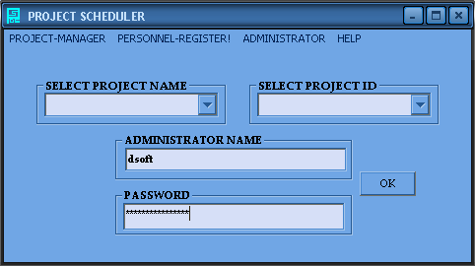

NEW ADMINISTRATOR ENTRY
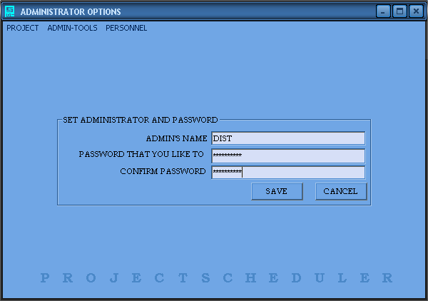

NEW PERSON ENTRY & PERSONNEL DATABASE VIEW
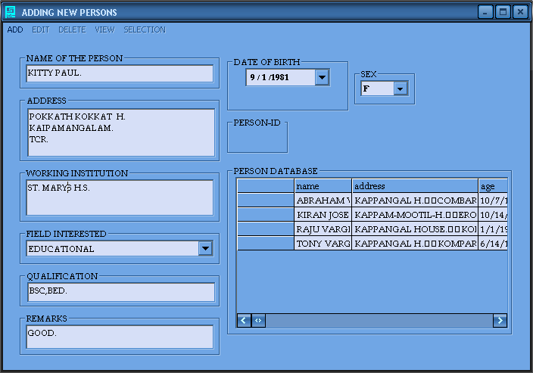

NEW PROJECT ENTRY
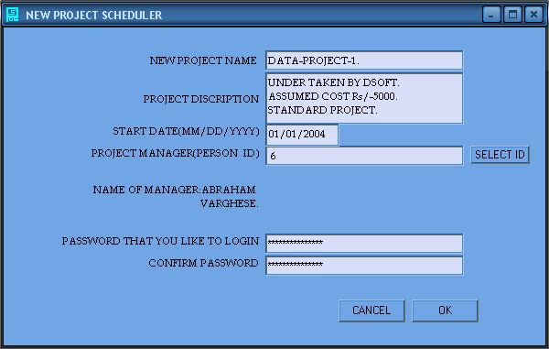

SUBTASK-ENTRY/SUBTASK-DELETION
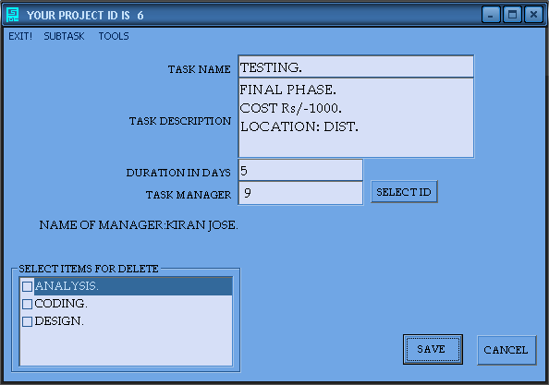

SUBTASK’S RELATIONSHIPS ENTRY
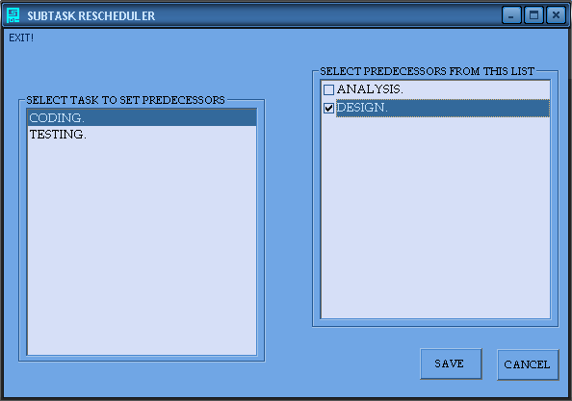

NEW PERSONNEL-REGISTER ENTRY
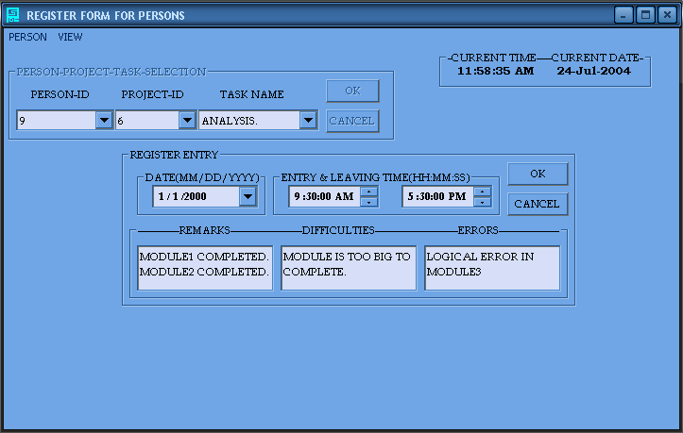

STATUS UPDATION OF A TASK
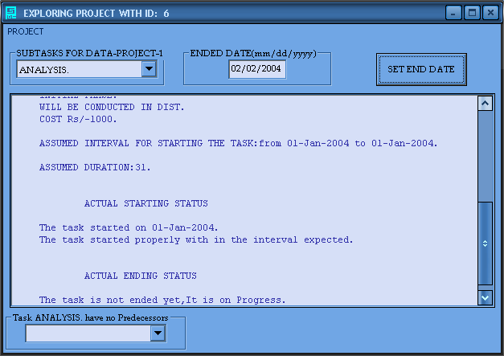

UPDATION OF PROJECT/TASK DESCRIPTION
&
SIMPLE-PROJECT/TASK VIEW
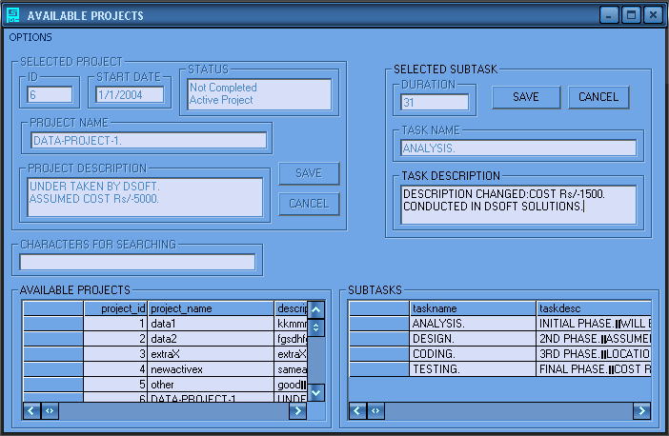

CHANGING PROJECT/TASK MANAGERS
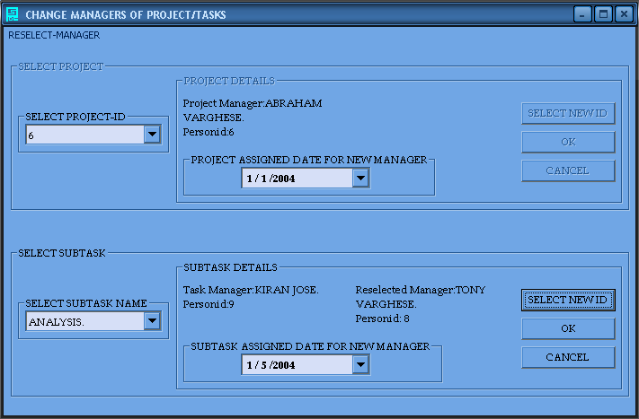

CHANGING PROJECT’S START DATE/TASK’S DURATION
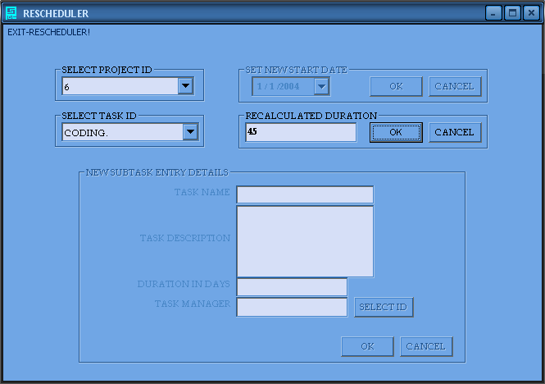

ADDING NEW TASK TO EXISTING PROJECT & SETTING NEW RELATIONS
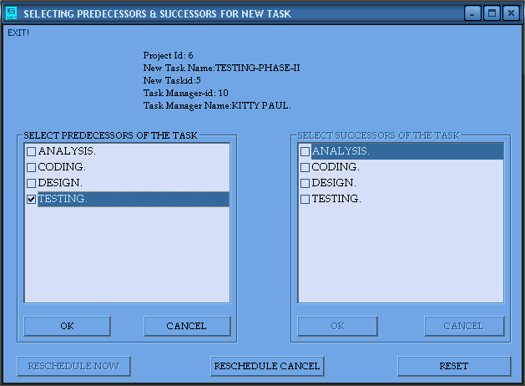

GANTT-CHART-GENERATOR
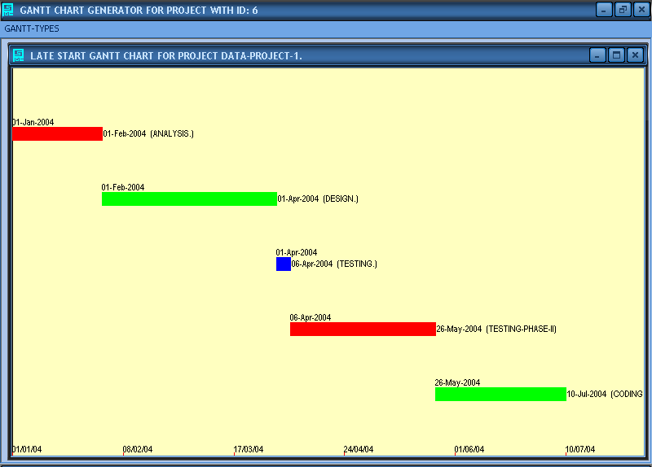

AON-GRAPH-GENERATOR
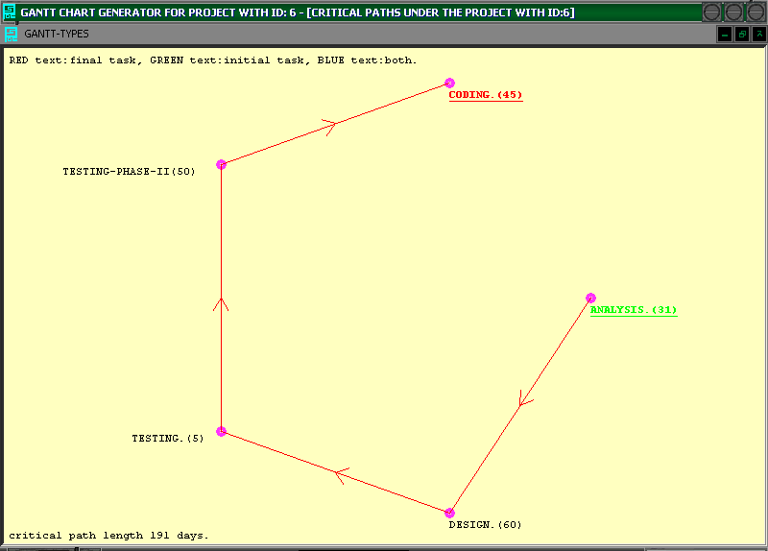

PERSONNEL-REGISTER VIEW
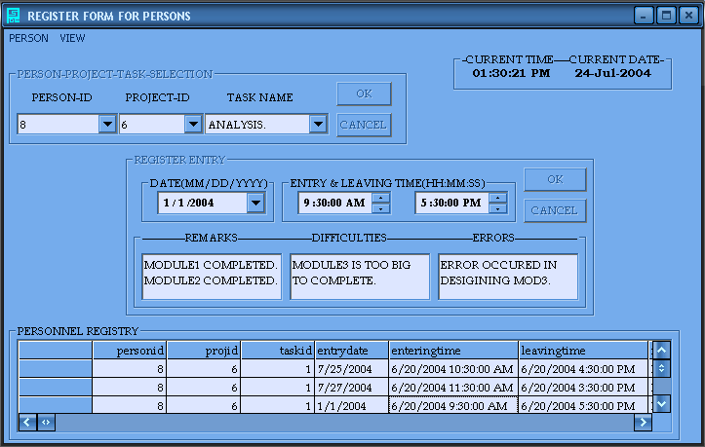

PERSONNEL-REPORT
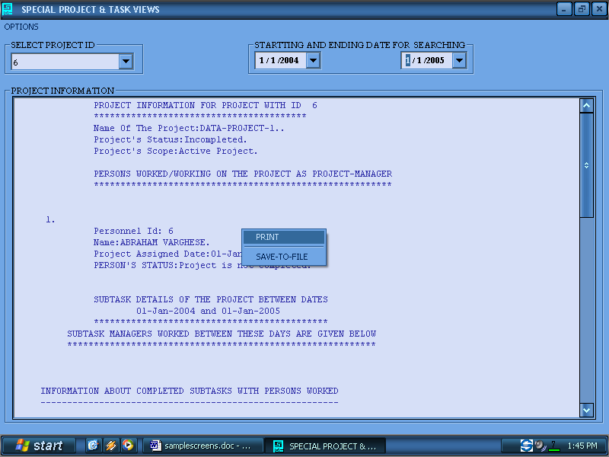

ALL-PROJECT-REPORT
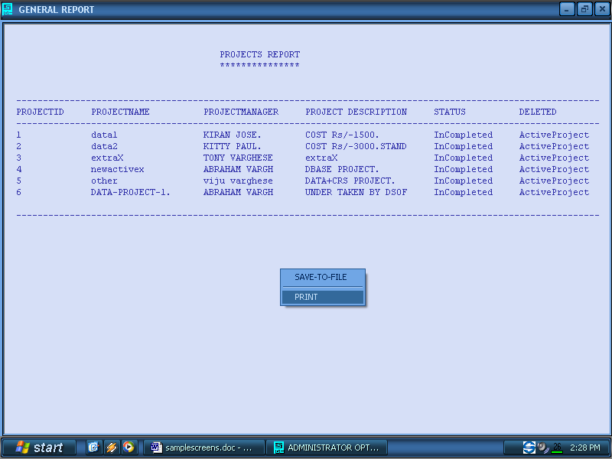

SINGLE-PROJECT-REPORT
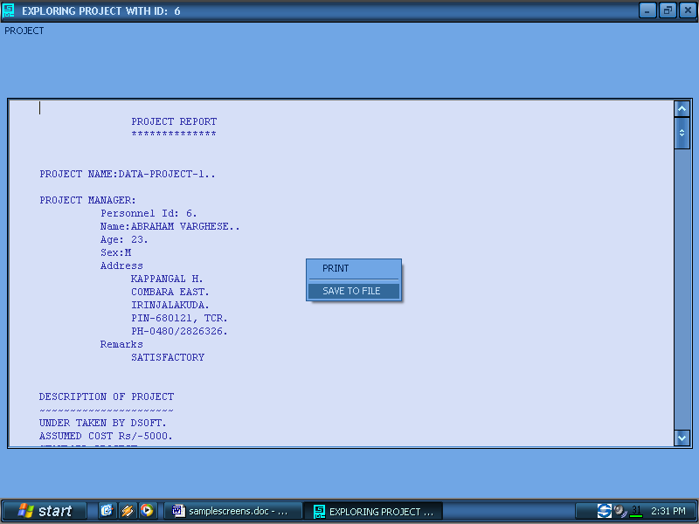

RELATED-TASK-REPORT/TASK-REPORT
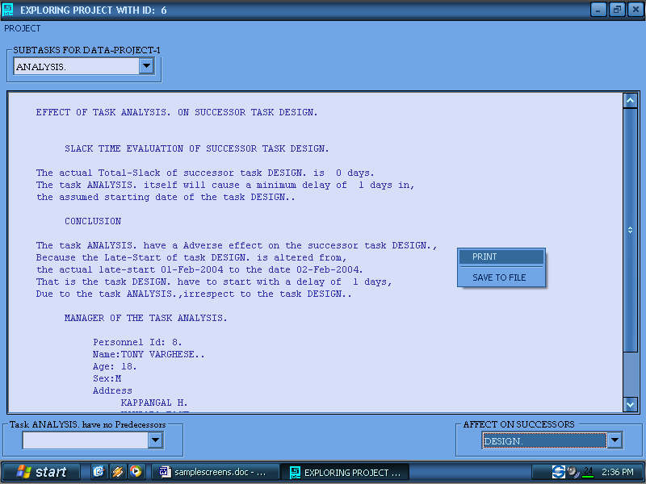

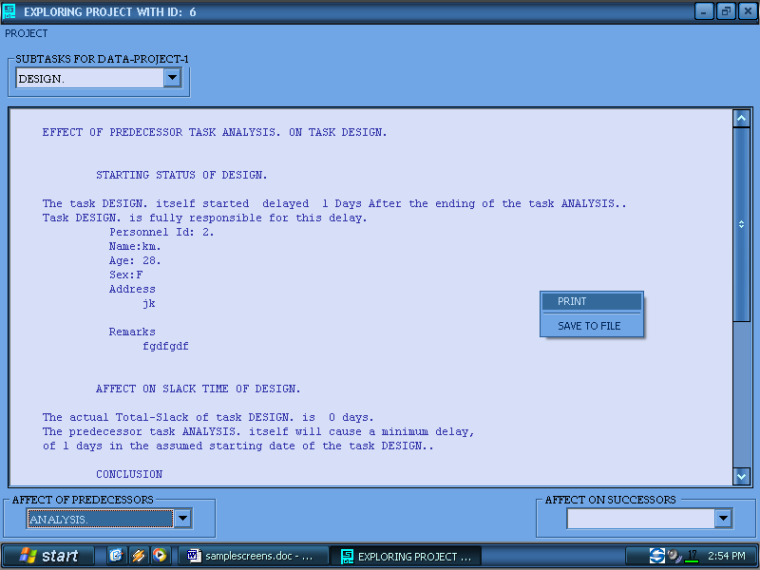

GRAPHICAL-ANALYZERS
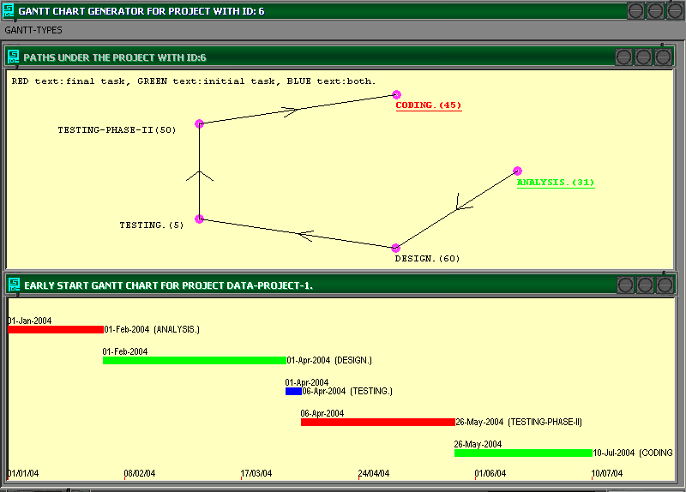

DATE-CALCULATOR-DEMO
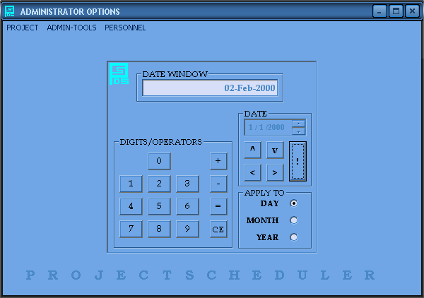

CONCLUSION

I here by conclude that the Project Work on the project called ‘PROJECT_SCHEDULER’, assigned to me is completed honestly and most sincerely with the help the Management of DePaul Institute of Science & Technology and DSOFT SOLUTIONS, the teaching & non-teaching staffs of DePaul Institute of Science & Technology, my lovable friends, my family members and all the one who helped me to complete this project directly and indirectly.

During the project work, I often came across very difficult situations in the development of certain modules. I like to expose some of those modules and their related development logic here. Among those modules the modules called the AON-GENERATOR, GANTT-GENERATOR and the PATH-FINDER which comes under the section AON-GENERATOR; got the highest time during my Project Period. First I like to explain about the AON-GENERATOR with the diagram that I used to develop this module.

For more information about AON, please refer APPENDIX-B.

SKELTON OF AON-GENERATOR

The first step in the generation of an AON diagram constitutes determining the Angles for the subtasks under the project, so that we can fix the subtasks around an elliptical structure and no two subtasks have the same angle. For that we divide the total angle around the Ellipse; i.e. 360-Degree into ‘N’ different parts where ‘N’ is the total number of subtasks under the project.

We fix the ‘Current-Angle’ angle to ‘0-DEGREE’, and then for each new task encountered we will assign the ‘Current-Angle +360/N’ to that task, and that angle is called ‘ANGLE-OF-TASK’. In this way each task gets a unique angle around the ellipse.
Semi major axis: r1
Semi minor axis: r2
Assumed-Origin:(0,0)
Task1:(xb,yb)/Angle=Ti
Task2:(xe,ye)/Angle=Tj
(x2,y2)
(xk1,yk1)
(xk2,yk2)
(x1,y1)/angle=Ti-45
(xmid,ymid)
(x3,y3)/angle=Tj+45
y=m1x+c1
y=m2x+c2
line-1
line-2
line-3
(x4,y4)
FORM
d1
d1
Assumed-FORM-Origin
X-Axis
Y-Axis
FORM-Y-Axis
FORM-X-Axis
DEG-0
DEG-90
DEG-180
DEG-270
I first tried a circle instead of an ellipse, but later I found out that an ellipse can use the maximum FORM-AREA than a circle, if the FORM is not a perfect SQUARE.

Now to represent the adjacency or successor or predecessor relationships among the tasks, we will draw a ‘Directed-Arrow’ from the Begin-Task to End-Task. The Cartesian-Coordinate of the required line can be found out directly from the ‘ANGLE-OF-TASK’ of the subtasks specified. In the diagram these are the points:
(xb, yb) & (xe, ye).
Xb= r1 x cos(Ti), Yb=r2 x sin(Ti),
Xe= r1 x cos(Tj),Ye=r2 x sin(Tj) .

After Drawing the Line, the next tedious step is to draw the ‘Directed-Arrow’ on the middle of the line just constructed. Since we are struggling with POLAR-COORDINATES there is no chance to develop a common solution for this using Cartesian-Coordinate. Later I found out a solution as follows.

Suppose ‘Task1’ & ‘Task2’ are the two tasks in the figure and the ‘Directed-Arrow’ should be drawn from ‘Task1’ to ‘Task2’. The ‘Angle-Of-Task’s are ‘Ti’ and ‘Tj’ for ‘Task1’ and ‘Task2’ respectively. What we will do is to find two points on the ellipse: (x1,y1) & (x3,y3), the first one is located at an angle ‘Ti-45’ and the second one located at an angle ‘Tj+45’ . The next step is construct two lines: ‘LINE1’ and ‘LINE2’ as depicted in the figure using the above mentioned points and the ‘Mid-Point’ of the line ‘LINE3’, the indicator from ‘Task1’ to ‘Task2’. The mid point of a line whose end coordinates ((xb,yb) & (xe,ye)) are known can be found out by the formula:

Xmid=(xb+xe)/2 & Ymid=(yb+ye)/2.

Constructing the lines means finding their slope ‘M’ and the ‘X-intercept’: ‘C’. If the end points of a line is known and let it be (Xi, Yi) & (Xj, Yj), the equation to that line can be found out by first calculating the slope ‘M’ and next ‘C’ as:

M=(Yi-Yj)/(Xi-Xj) & C=(Xi*Yj-Xj *Yi)/(Xi-Xj).

So using these equations we construct ‘LINE1’ & ‘LINE2’ using the points (xmid,ymid)-(x3,y3) and (xmid,ymid)-(x1,y1). Let the equations of lines are respectively:

Y=m2X+c2 & Y=m1X+c1.

Let the ‘Directed Arrow’s length should be ‘d1’ as shown in the figure, so that we have to draw two lines from (xk1,yk1) to (xmid,ymid) and (xk2,yk2) to (xmid,ymid); to construct the ‘Directed Arrow’. Therefore the aim is that to find a point in ‘LINE1’ say (xk2,yk2) such that it’s distance from (xmid,ymid) is ‘d1’. For that we will solve the ‘Distance-Formula’. Formulizing above criteria results in:

Sqrt(sqr(xk2-xmid)+sqr(yk2-ymid) )=d1.

But ‘yk2=m2*xk2+c2’, substituting and solving, we get the general solution as;

Xk2=xmid+(d1/sqrt(1+sqr(m2)));
Xk2=xmid-(d1/sqrt(1+sqr(m2)));

So solving these two equations we get two solutions or two points, one point between (xmid,ymid)-(x3,y3) and the other between (xmid,ymid)-(x2,y2). We need only the latter one, the real (xk2,yk2) in the figure. For that we will check which one of the two points is lying between (xmid,ymid)-(x2,y2). And the point that satisfies above criteria is taken for (xk2,yk2). For that we have to find (x2,y2), which is the ‘Point of Intersection’ of ‘LINE1’ and the Ellipse. So that point can be found out by solving ‘LINE1’ with the Ellipse. That means solving the equations:

Sqr(X/r1) + Sqr(Y/r2)=1 & Y=m2*X+c2.

The solution is a Quadratic-Equation which gives the two intersectional-points between the Ellipse and the ‘LINE1’. The solution is calculated from the above equation as:

X=-(sqr(r1)*m2*c2)+r1*r2*sqrt(sqr(r1*m2)+sqr(r2)-sqr(c2)).
Sqr(r1*m2) +Sqr(r2)

X=-(sqr(r1)*m2*c2)-r1*r2*sqrt(sqr(r1*m2)+sqr(r2)-sqr(c2)).
Sqr(r1*m2) +Sqr(r2)

Y=m2*X+c2.

The two points of the solution will be (x2,y2) & (x3,y3), and by suitable selection procedure we will select (x2,y2).

A similar approach is applied to find (xk1,yk1) which is less complex than the above one. In this case we are directly given with the point (x1,y1), and there is no need to solve ‘LINE2’ and the Ellipse. So if we remove the latter procedure mentioned and substitution of ‘m1’ for ‘m2’ and ‘c1’ for ‘c2’ make it clear that the above explained procedure can be used with a little modification.

All the procedure described above is valid only if ‘Ti<=Tj’. That means the Beginning-Angle should be less than or equal to the Ending-Angle. If the converse is true then (i.e. ‘Ti>Tj’.) then the above procedure is used with a little change. That is we take ‘Ti+45’ instead of ‘Ti-45’ and ‘Tj-45’ instead of ‘Tj+45’. This conversion or change will enable us to use the same former procedure described above, and this case is depicted as SECTION-B in the following figure.

Ti
Tj
SECTION-A
Ti'
Tj'
SECTION-B
Ti'+45
Tj'-45
Ti-45
Tj+45

EXCEPTION NO: 1

Consider the above case (SECTION-A) of AON-GENERATOR. In the above situation (xk2, yk2) is not between the line segment (xmid,ymid)-(x2,y2). In such a case there is failure to find a point for (xk2, yk2) since neither of two points, those which are struggling to become (xk2, yk2) will satisfy the above mentioned criteria. In such an exceptional situation, i.e. all the two points are outside the range, we will check which one of them satisfy the condition, such that the point (x2,y2) will come between (xmid,ymid) and the POINT which is struggling to become (xk2,yk2). If the condition is satisfied that point is taken for (xk2, yk2). Also this exception is also applicable to the point (xk1, yk1). In that situation also the above explained procedure can be applied with a change of (xk2, yk2) to (xk1, yk1) and (x2, y2) to (x1, y1).

EXCEPTION NO: 2

Ti=45
Tj=315
Tj-45
Ti+45
Tj+45
Ti-45

Consider the case, depicted in the figure. Here, if we use the normal procedure, ‘Ti-45’ and ‘Tj+45’ will converge to ‘0’ as in the figure and since both the Angles are converges to Zero we cannot draw the ‘Arrow-Indicator’ on the line joining ‘Ti & Tj’. In such a situation we make use of the same algorithm described above with a little modification. That is we take ‘Tj-45 & Ti+45’ instead of ‘Tj+45 & Ti-45’ respectively. Also we cannot draw the ‘Arrow-Indicator’ if (0<=Ti<=45 & 315<=Tj<=360) or (0<=Tj<=45 & 315<=Ti<=360). In such a situation also, we make use the same modification just described above.

NOTE:
In all the cases the origin is taken as (0,0), only for simplicity. But in practice we have to translate the coordinate origin to some where in the First-Quadrant. This change can be accommodated by adding a displacement to the X & Y values, which are generated from calculations using (0,0) as origin. Let (X,Y) be a calculated point in normal X-Y Plane, which assumes (0,0) as coordinate origin. We can place this point in a new X-Y Plane, which is generated by shifting the coordinate origin (0,0) to (Xc,Yc). This is done by adding Xc to X and Yc to Y.
I.e. Xnew=X+Xc & Ynew=Y+Yc.

Where (Xnew,Ynew) is the translated position of (X,Y) in the new plane.

The main diagram is depicted in a sample FORM, which has the origin at the top-left corner and that is the real origin or the coordinate origin (0,0) and in the figure it is represented as FORM-ORIGIN. To create graphics we have to translate this origin somewhere to the middle of the form that needs adding a positive displacement to both the X & Y values that are calculated according to the coordinate origin (0,0) or FORM-ORIGIN. In the figure the translated origin is the ASSUMED-ORIGIN. For simplify the calculations, ASSUMED-ORIGIN is taken as the FORM-ORIGIN and hence it is (0,0). i.e. No translations are performed.

GANTT-CHART-GENERATOR

Gantt chart is prepared on the basis of date calculations. The major step is converting the task and its associated dates into Cartesian coordinates. Here X-axis is meant for represent dates and the Y-axis for representing the Tasks. For that we will divide the Y-axis into ‘N+1’ parts, where ‘N’ is the total number of Tasks under the Project, and the parts are assigned to the Tasks under consideration, so that each Task have a unique part for itself. Hence we got the Y-coordinate for each Task.

The next step is calculating the X-coordinates. For that we will convert the ‘Date-Values’ to numerical values. We will find the Maximum and Minimum of ‘Date-Values’ associated with the Tasks. The ‘Minimum-Date-Value’ is assumed as the ORIGIN-X-Coordinate i.e. ‘0’. The other ‘Date-Values’ including the ‘Maximum-Date-Value’ is subtracted from the ‘Minimum-Date-Value’ to get their OFFSET from the ‘Minimum-Date-Value’ and that OFFSET is their corresponding X-Coordinate value. The X-axis’s length is taken as the OFFSET of the ‘Maximum-Date-Value’ from the ‘Minimum-Date-Value’. Now each Task’s Start & End dates OFFSET are calculated, and let them are ‘X1’ & ‘X2’. This task has a unique Y-coordinate also; let it be ‘Y’. Then a line is drawn from (X1,Y) to (X2,Y). This process is repeated for other Tasks also.

The entire ‘Project-Scheduler’ is working based on days, so the OFFSETS are taken on the ‘Day’ basis. That is we will find the number of days between the ‘Minimum-Date-Value’ and the ‘Date’ for which the OFFSET is fought.

THE-PATH-FINDER

The main aim of the sub module called ‘PATH-FINDER’ is to determine the ‘CRITICAL-PATHS’ in a Project-Network. But the same module is used to draw all the PATHS and CRITICAL-PATHS in a Project-Network using AON-GRAPH. So I put this module under the module, AON-GENERATOR.

Finding PATHS in a Project-Network means to find all the routes from the INITIAL-TASK to the ENDING-TASK. So we can think about a DATA-STRUCTURE for PATHS which is TWO-DIMMENSIONAL in nature. The rows represent the different paths and each column in each row represents a TASK in that PATH. The preceding and succeeding column contents of the current column indicate the predecessor and successor TASKS of the Current TASK in the PATH under consideration. And most generally this DATA-STRUCTURE is simply a MATRIX whose rows indicates different paths and columns in a row indicates the TASKS comes under that path, and the ordering of the TASKS under the path is same as that of their column number order. And this MATRIX is named as the ‘PATH-TABLE’. For example if there is a PATH as:

A
B
C

Then the ‘PATH-TABLE’ and the ROW corresponding to the PATH described in the above figure is depicted as follows (row=1, here).Here an ‘E’ is included after the last TASK ‘C’ which is an ‘END-OF-PATH’ indicator. Here the ‘END-OF-PATH’ indicator may be a special character or most probably a negative integer, usually -1. Normally we use integer-codes for the tasks instead of their names such as ‘A’, ‘B’, e.t.c for simplifying the data structure and easy retrieval and calculations.

Sno | 0 | 1 | 2 | 3 | 4 | 5 | 6 | 7 | 8
0 | B | - | X | - | - | E
1 | A | B | C | E
2 | - | Y | - | - | E
3 | A | C
4

So now we are in a position to understand the ALGORITHM for finding all the PATHS in the Project-Network. Initially we take all the INITIAL-TASKS of the Project and put them in the ‘0th COLUMN’ of succeeding rows, starting from the ‘0th ROW’. Now we iterate each row, by taking all the ‘SUCCESSOR TASKS’ of the ‘TASK’ which resides in the last column position occupied, of the row under consideration. For ex: if we consider ‘ROW 3’ in the above figure, ‘C’ is the TASK for which we will take the ‘SUCCESSOR TASKS’. Then the first one of the selected ‘SUCCESSOR TASKS’ is placed in the next available column position of the row under consideration. In the previous example it is the CELL addressed by ‘(3,2)’, i.e. ROW=3 & COLUMN=2.

If there is no ‘SUCCESSOR TASK’ for the TASK under consideration, then we fill the available column position with the ‘END-OF-PATH-INDICATOR’, ‘E’; and we select the succeeding ROW for iteration. If we already reached the LAST-ROW then we move on to the FIRST-ROW to start a new iteration. If there is more than one ‘SUCCESSOR TASK’ for the ‘TASK’ then the remaining tasks are stored in the PATH-TABLE using the following procedure.

For each of the remaining ‘SUCCESSOR TASK’ we will find the next available ROW in the PATH-TABLE. In the previous example the ‘ROW 4’ is free, so that we can take that ROW. The next step is to copy the entire ROW (The row, whose LAST-COLUMN is used for the selection of ‘SUCCESSOR TASKS’) except the LAST-COLUMN to the NEW-ROW that we just founded out. After the copying, we add the remaining ‘SUCCESSOR TASK’, which comes under the remaining list of ‘SUCCESSOR TASKS’ to the next available COLUMN in the NEW-ROW. After all the remaining ‘SUCCESSOR TASKS’ are stored in this way, we will go for another row for a new iteration.

This CYCLIC-PROCEDURE ends if all the ROWS in the PATH-TABLE contain the ‘END-OF-PATH-INDICATOR’, ‘E’ in the LAST-COLUMN position. That means all the PATHS under the Project-Network are successfully founded out.

We can extract the CRITICAL-PATHS from this PATH-TABLE, by simply looking for PATHS which having a length equals to the PROJECT-DURATION.

The search for NEW-ROWS and NEW-COLUMNS indicating that, the PATH-TABLE is a DYNAMIC-MATRIX, which will grow up by ROWS and COLUMS during the time of execution. So during the development of this module, I have to consider the Memory-Management-Techniques, Runtime-Memory-Allocation, and Runtime-Memory-Reallocation in VISUAL BASIC 6.0.

BIBLIOGRAPHY
- MANAGEMENT GUIDE TO PERT & CPM;
JEROME.D.WIEST & FERDINAND.K.LEVY.

- SENN, ANALYSIS AND DESIGN OF INFORMATION SYSTEM;
MC.GRAW HILL BOOK COMPANY, 1989.

- AN INTRODUCTION TO ORACLE;
IDPM, SALEM.

- PROJECT MANAGEMENT WITH CPM & PERT, 2ND EDITION;
J.J.MODER & C.R.PHILLIPS;
(NEW YORK: REINHOLD PUBLISHING CORP. , 1970).

- EXTENSIONS OF THE CRITICAL PATH METHOD THROUGH THE APPLICATION OF INTEGER PROGRAMMING;
DEPARTMENT OF CIVIL ENGINEERING, UNIVERSITY OF ILLINOIS,
JULY 1963.

- CBSE MATHEMATICS; S.ABRAHAM & N.J.JACOB.

- DATABASE SYSTEM CONCEPTS,
NEW YORK; MCGRAW-HILL, 1986,
H.F.KORTH & A.SILBERSCHATZ.

